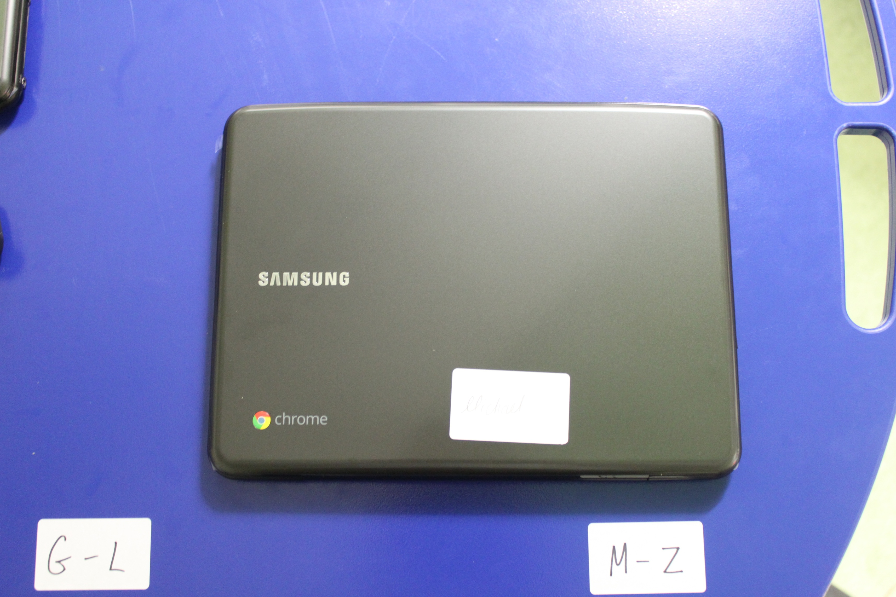

Place me right here in piles of four!

**Remember**

Chrome on top of Chrome!



Place me right here in piles of four!

**Remember**

Chrome on top of Chrome!